Tab 1
Module Name: DemoBlaze
Test Case ID: 3
Webpage URL: https://www.demoblaze.com

Scenario ID: 1
Scenario: View products
Test Steps:
1. Open DemoBlaze
2. Go to Homepage
3. Check Products section
4. Check Products display or not
Screenshots:
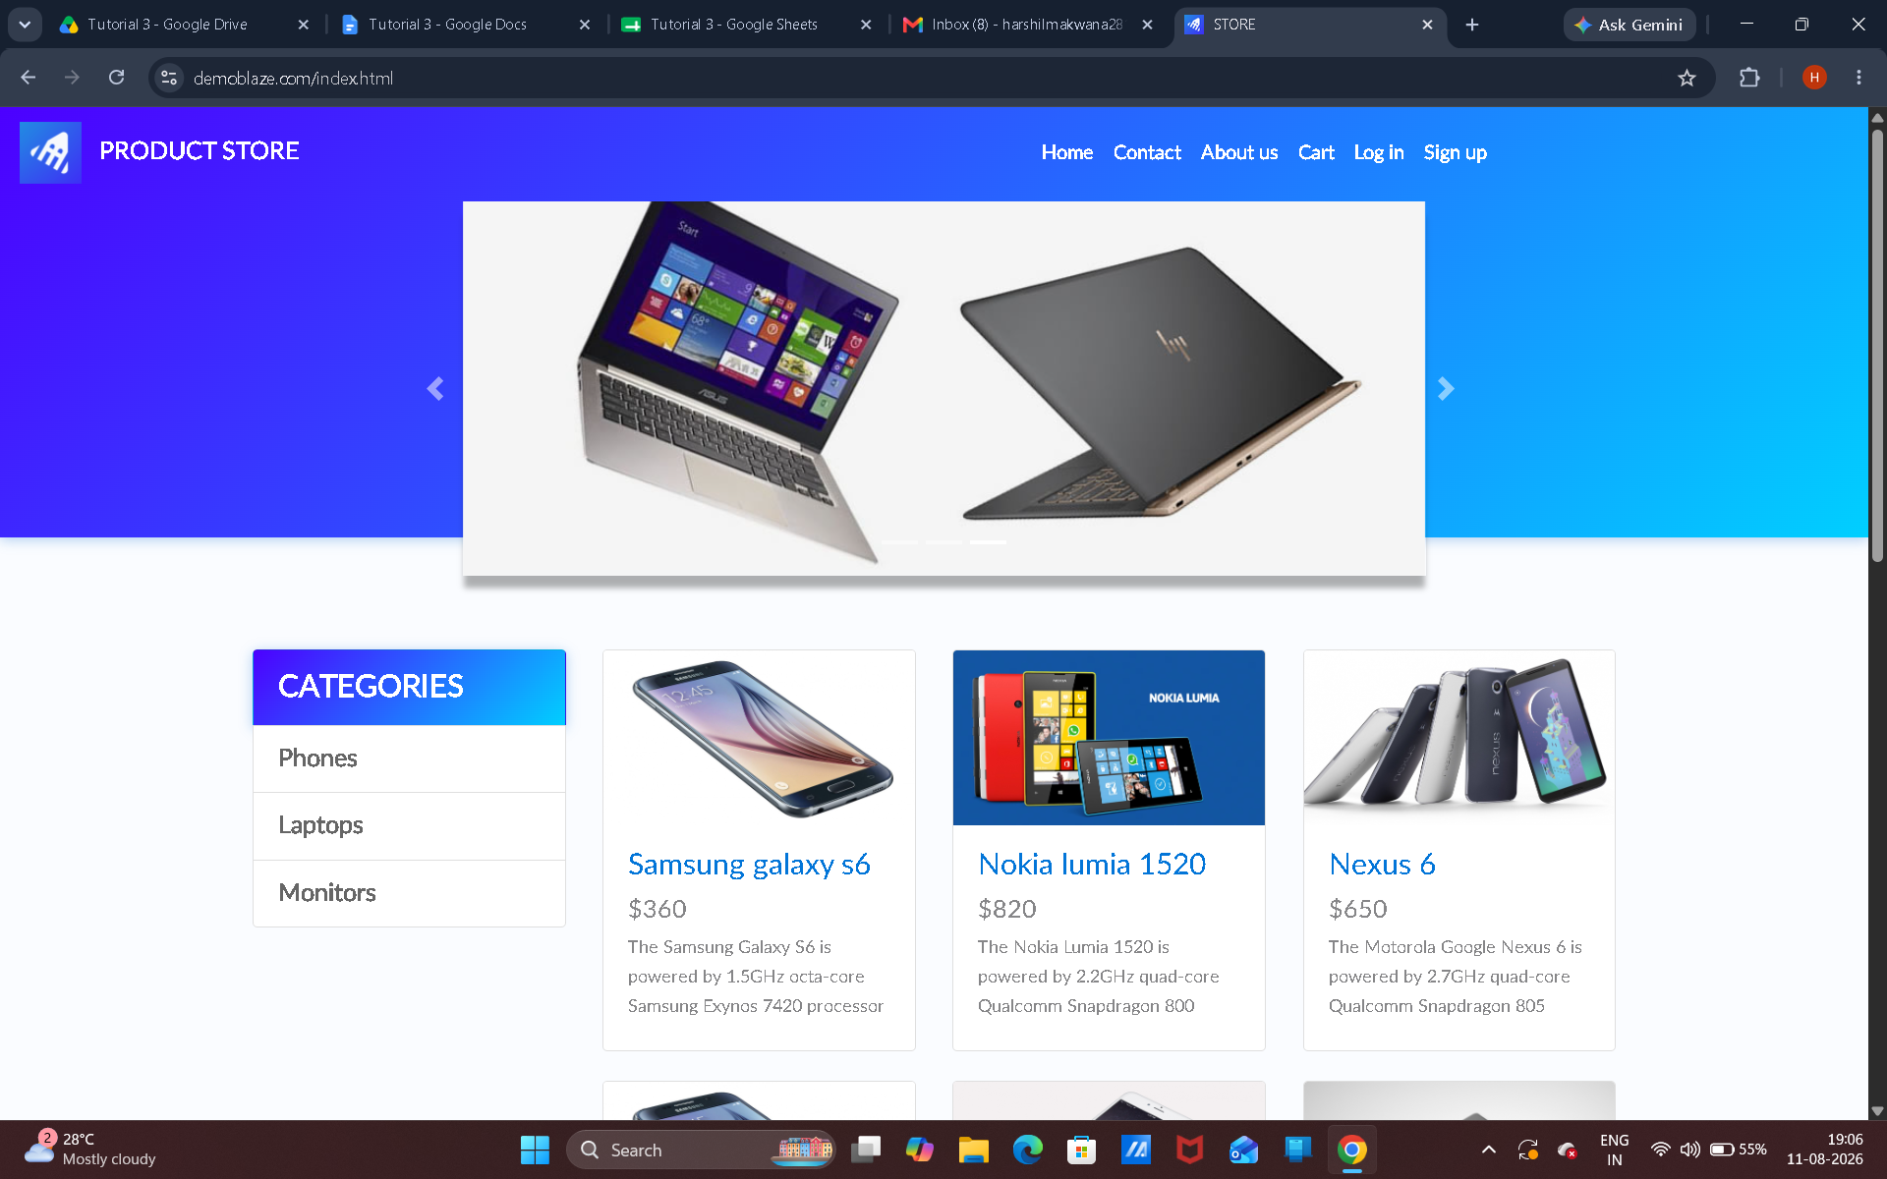

Scenario ID: 2
Scenario: Select product
Test Steps:
1. Open DemoBlaze
2. select any Product
Screenshots:
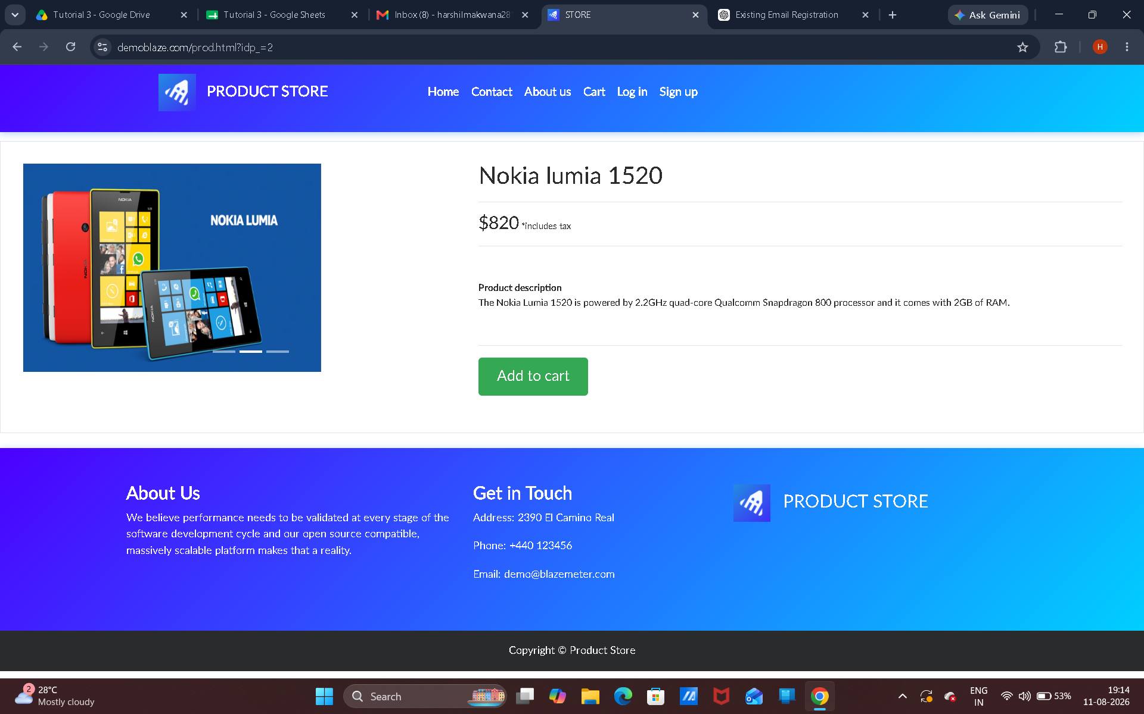

Scenario ID: 3
Scenario: View product details
Test Steps:
1. Open DemoBlaze
2. select any Product
3. check product name , price , description , Image
Screenshots:

Scenario ID: 4
Scenario: Add product
Test Steps:
1. Open Homepage
2. Click Add to cart button
3. Check Confirmation message
Screenshots:

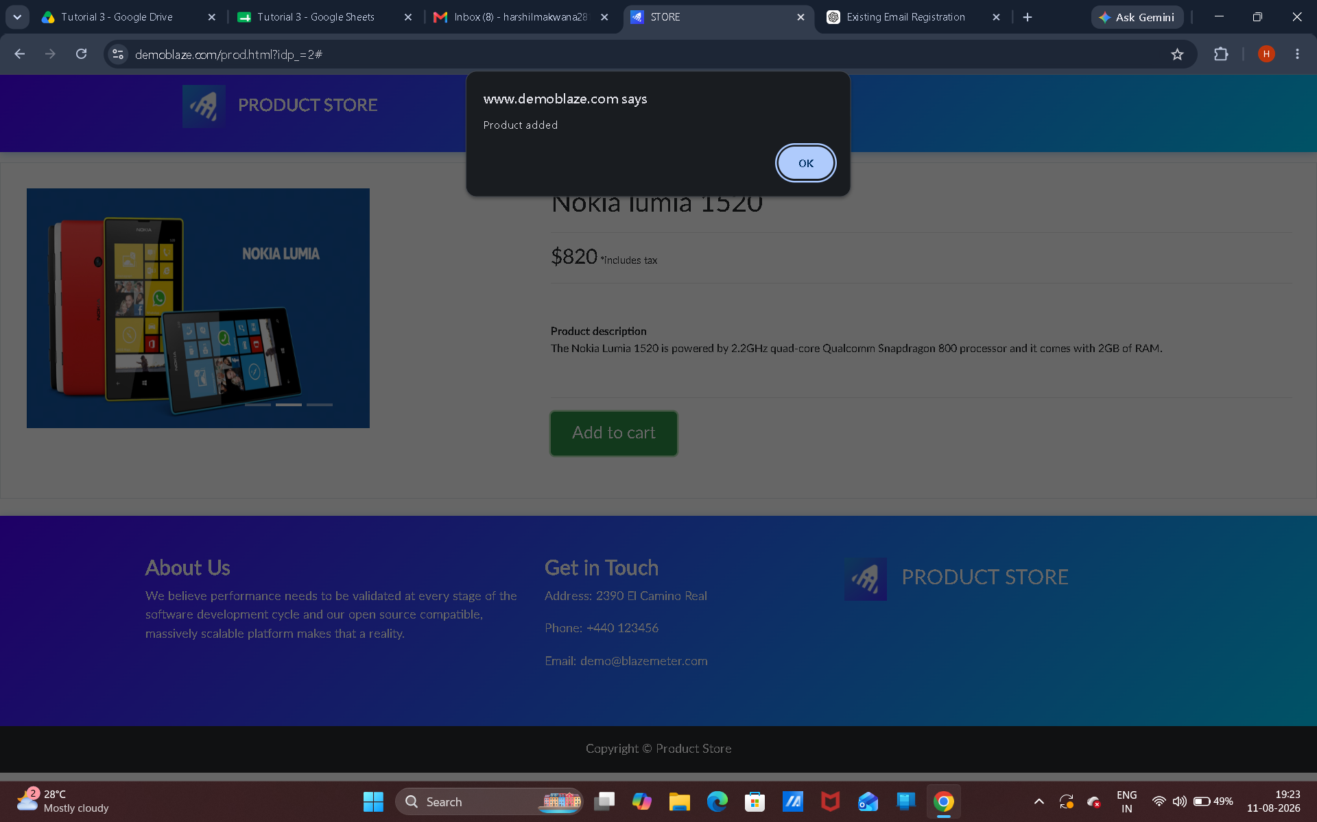

Scenario ID: 5
Scenario: Open cart
Test Steps:
1. Open Homepage
2. Click Add to cart button
3. Open cart option
Screenshots:

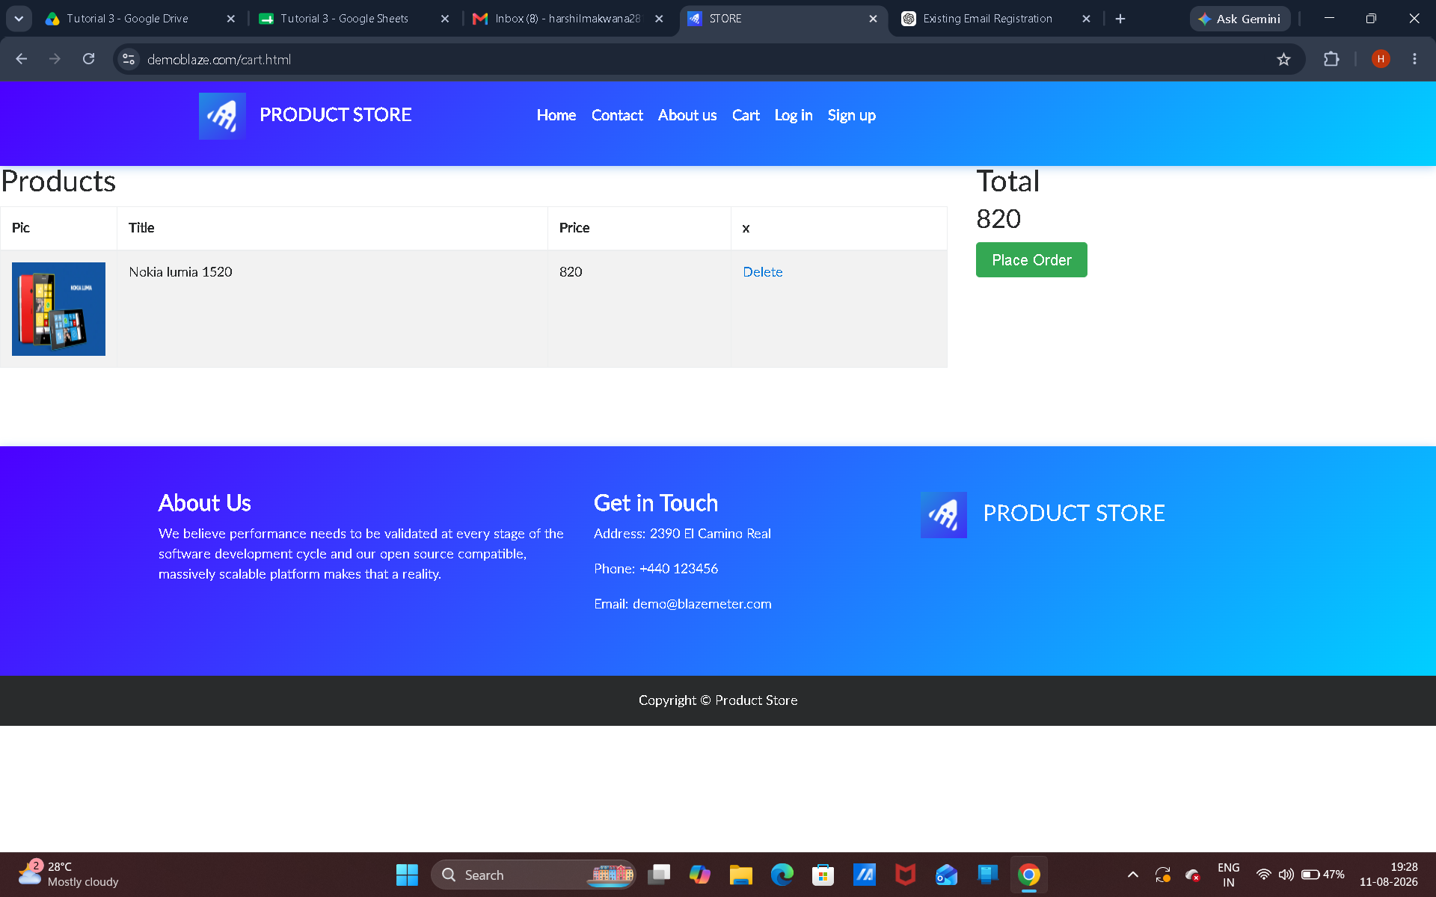

Scenario ID: 6
Scenario: Verify product in cart
Test Steps:
1. Open Homepage
2. Click Add to cart button
3. Open cart option
4. check cart item
5. check item price
Screenshots:

Scenario ID: 7
Scenario: Remove product
Test Steps:
1. Add product in the cart
2.Open cart
3.Remove the product
Screenshots:

